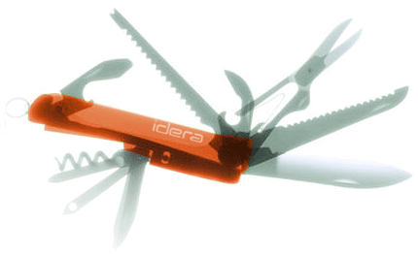

**Specification**

**for**

Modified by Vicky Harp

**3/5/10**



Proprietary and Confidential to BBS Technologies, Inc.

**© 2010 BBS Technologies, Inc.; all rights reserved.**

# Revision history:

|  |  |  |
| --- | --- | --- |
| **When?** | **Who?** | **What?** |
| 2/4/2010 | Kurt | First Draft |
| 2/22/2010 | Kurt | Revisions |
| 3/5/2010 | Kurt | Final |
| 3/19/2010 | Vicky | Updates for changes to feature. Removed correlated metrics and added a day for repository work. |
| 5/12/2010 | Vicky | Added Appendix 1 |

# Table of Contents

Wait Stat Monitoring i

Kurt Goolsbee i

Modified by Vicky Harp i

1. Revision history: ii

2. Table of Contents iii

3. Requirements 4

3.1. Overview/Purpose 4

3.1.1. Related Customer Requests 4

3.2. Target Users 4

3.3. Feature/Function Market Requirements 4

3.3.1. Required Functions 4

3.4. FAQ 4

3.5. Open Issues 4

4. Functional Design 5

4.1. User Interfaces 5

4.2. Installation and Upgrade 6

4.3. Permissions and other Required Configuration 6

4.4. Licensing Issues 6

4.5. Dependencies 6

5. Internal Design 6

5.1. Architecture 6

5.1.1. Collection Service 6

5.1.2. Management Service 7

5.1.3. Desktop Client 7

5.1.4. Repository 7

5.2. Installation Issues 7

5.3. Schedule 7

5.3.1. Work Breakdown and Sizing 7

5.3.2. Areas of Risk 8

6. Quality Assurance Considerations 8

6.1.1. Overview 8

6.1.2. Developer-Created Unit Tests 8

7. Documentation Consideration 8

8. Appendix 1 – Implementation Notes 9

# Requirements

## Overview/Purpose

An analysis of Waits indicates where SQL Server is spending lots of time waiting. By correlating the areas of the server that are waiting with other statistics it is possible to help narrow down possible causes of the waits. For instance, lots of time waiting on disk resources could indicate that you have a disk problem.

Competitive SQL Server monitoring products have the ability to monitor SQL Server wait statistics.

### Related Customer Requests

Unable to find a PR for the request but I have a pre-sale request for a customer currently using Symantec I3 to add similar functionality to SQLdm.

## Target Users

This feature will benefit database administrators looking to tune their SQL Servers by reducing the time the server has to sit idle waiting for resources.

## Feature/Function Market Requirements

### Required Functions

Users should be able to view the data in real-time or historical mode.

Users should be able to view waits by resource, signal or total wait time.

Users should be able to view wait statistics summed over a period of time by category.

Users should be able to view detailed waits for a given category.

Users should be able to view detailed and categorized wait statistics using the history browser

Users should be able toe view the definition of a wait type within the view

~~Users should be able to visualize how sessions are moving between the statuses of Running/Runnable/Waiting.~~

## FAQ

None.

## Open Issues

Are we going to add a pie chart as suggested in comment TM6? If so where does it go and how to you choose to see it? Answer: There will either be a dropdown or a tab that will change the top chart to a pie.

# Functional Design

## User Interfaces

|  |  |  |  |
| --- | --- | --- | --- |
| Category | Wait | Wait Time in Secs | Definition |
| IO | PAGEIOLATCH_SH | 627.2 | This is a wait… |
| Locks | LCK_M_X | 28842.2 | This is a wait… |

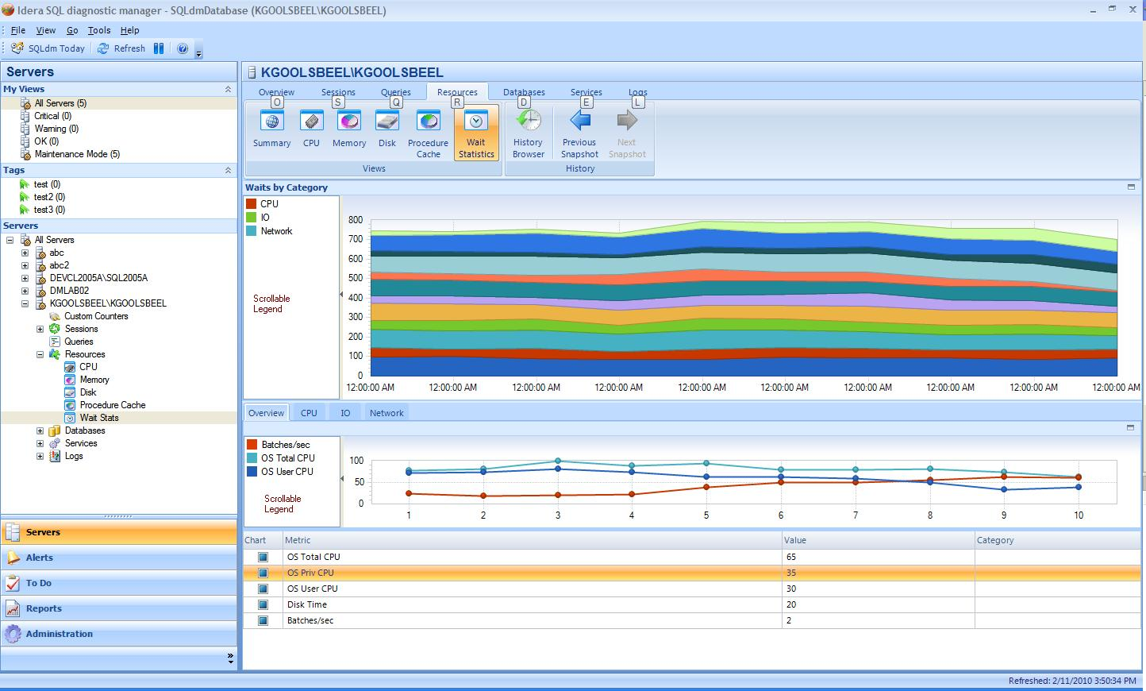

This view will be available in both real time and history browser modes.

The modes for the top chart will be selectable in the bar directly above the top chart. There will 2 drop downs available. The first will allow you to select either all categories or detailed waits for a single category. If we decide to include a pie chart then there will need to be an additional option to allow for that option. The second drop down will allow you to select which component of the wait – resource, signal or total wait time.

The bottom portion of the view will display a grid of detailed wait statistics which will include the wait category and wait definition. Both the definition and the category will be stored in the repository for ease of modifying these if they turn out to be incorrect.

We will be adding a new tab to the ribbon control called Waits. The Server Waits view will be the default view for the Waits tab. The other tab available will be the Query Waits view (separate spec). The new tab will require changes to the navigation tree control.

## Installation and Upgrade

No special considerations.

## Permissions and other Required Configuration

No special considerations.

## Licensing Issues

No special considerations.

## Dependencies

No special considerations.

# Internal Design

## Architecture

### Collection Service

Add a real-time probe to collect and summarize wait statistics.

Add similar logic to the scheduled refresh for collecting wait statistics to store historically.

Starting list of categories (sniped from SQLNexus). The last category IGNORABLE contains a list of wait types that can be ignored. This list may need some tweaking for 2008 R2.

WHEN wait_type LIKE 'LCK%' THEN 'Locks'

WHEN wait_type LIKE 'PAGEIO%' THEN 'Page I/O Latch'

WHEN wait_type LIKE 'PAGELATCH%' THEN 'Page Latch (non-I/O)'

WHEN wait_type LIKE 'LATCH%' THEN 'Latch (non-buffer)'

WHEN wait_type LIKE 'IO_COMPLETION' THEN 'I/O Completion'

WHEN wait_type LIKE 'ASYNC_NETWORK_IO' THEN 'Network I/O (client fetch)'

--WHEN wait_type LIKE 'CLR_%' OR wait_type LIKE 'SQLCLR%' THEN 'SQLCLR'

WHEN wait_type IN ('RESOURCE_SEMAPHORE', 'SOS_RESERVEDMEMBLOCKLIST') THEN 'Memory'

WHEN wait_type LIKE 'RESOURCE_SEMAPHORE_%' OR wait_type = 'CMEMTHREAD' THEN 'Compilation'

WHEN wait_type LIKE 'MSQL_XP' THEN 'XProc'

WHEN wait_type LIKE 'WRITELOG' THEN 'Writelog'

WHEN wait_type IN ('WAITFOR', 'LAZYWRITER_SLEEP', 'SQLTRACE_BUFFER_FLUSH', 'CXPACKET', 'EXCHANGE',

'REQUEST_FOR_DEADLOCK_SEARCH', 'KSOURCE_WAKEUP', 'BROKER_TRANSMITTER', 'BROKER_EVENTHANDLER', 'BROKER_RECEIVE_WAITFOR',

'BROKER_TASK_STOP', 'ONDEMAND_TASK_QUEUE', 'CHKPT', 'DBMIRROR_WORKER_QUEUE', 'DBMIRRORING_CMD',

'SLEEP_TASK', 'CLR_MANUAL_EVENT', 'CLR_AUTO_EVENT'

) --, 'DBMIRROR_DBM_EVENT') -- , 'SOS_SCHEDULER_YIELD')

THEN 'IGNORABLE'

### Management Service

Expose method for executing the real-time wait statistic probe. Wait stat configuration object to hold prior snapshot in order to calculate deltas.

Add code to store the wait statistics contained in the scheduled refresh snapshot.

### Desktop Client

A new view will be added to show the wait statistics. Feature wise, this view is similar to the Sessions/Locks view. I’d probably use it as a start since it has a chart and a grid and it supports history and real-time mode.

Custom Stuff:

Need a custom control for showing the chart legend. Was thinking a checked list box that is owner drawn. After the chart data is loaded, query the chart for legend information (color + series title) and use that to render the row. The idea is to create a scrollable legend.

Need to be able to collapse/restore the legend (separate control or possibly part of the legend control). Need to be able to signal the other legend so that it also collapses/restores itself.

### Repository

New Tables

* Wait Categories – List of wait categories
* Wait Types – List of wait types, their definitions, and a link to their category
* Wait Statistics – Main link table for wait statistics – one per collection
* WaitStatisticsDetails – Details associated with each Wait Statistics collection – one per wait type per collection

The grooming proc will need to be updated to groom the wait stats data. The data should be groomed at the time as the Server Activity data. We may need to allow for grooming the detailed wait stats table more frequently.

## Installation Issues

None

## Schedule

### Work Breakdown and Sizing

|  |  |  |
| --- | --- | --- |
| Component | Who | Sizing |
| Collection Service | Vicky | 2 days |
| Management Service | Vicky | 2 days |
| Repository | Vicky | 2 days |
| Desktop Client | Quentin | 12 days |
| Unit and Integration Testing | Quentin & Vicky | 2 days |
| **Categorizing Waits / Integrating Documentation** | **Quentin** | **3 days** |
| **Total** |  | **23 days** |

### Areas of Risk

Assignment of Wait Categories – new wait types can be added at any time by Microsoft. We will need to figure out how to categorize new types as they are added.

Volume of data – since we are storing detailed waits this could be upwards of a couple of hundred rows per refresh.

# Quality Assurance Considerations

### Overview

### Developer-Created Unit Tests

None expected

# Documentation Consideration

Documentation assistance will be required with formulating the definitions for the wait types.

# Appendix 1 – Implementation Notes

A number of changes were introduced during implementation in response to QA and PM requests and in order to fulfill technical requirements. For completeness these changes are delineated below. The same appendix is being included for both the Server Waits and Query Waits specifications.

* The Server Waits View will have both a line chart and a stacked chart, as well as the ability to change between the chart types
* In Server Waits and Query Waits the legend will reflect Wait Categories and not specific wait types
* While it was discussed on and off, no pie chart will be included for the Server Waits view in this release
* In the Query Waits view two buttons will be added to the ribbon:
  + A link to the Server Properties page to allow the query wait statistics to be configured
  + A button to define the number of records returned in the charts – the Top X, defaulting to 10
* Where labels for a chart are too long and are truncated, the series should be right-clicked upon to view the full label
* In Query Waits, when switching to timeline mode the top X series being shown will be the series shown in the timeline mode as well
* This specification refers to drill-throughs or links to other product areas. This is not being implemented in this release.